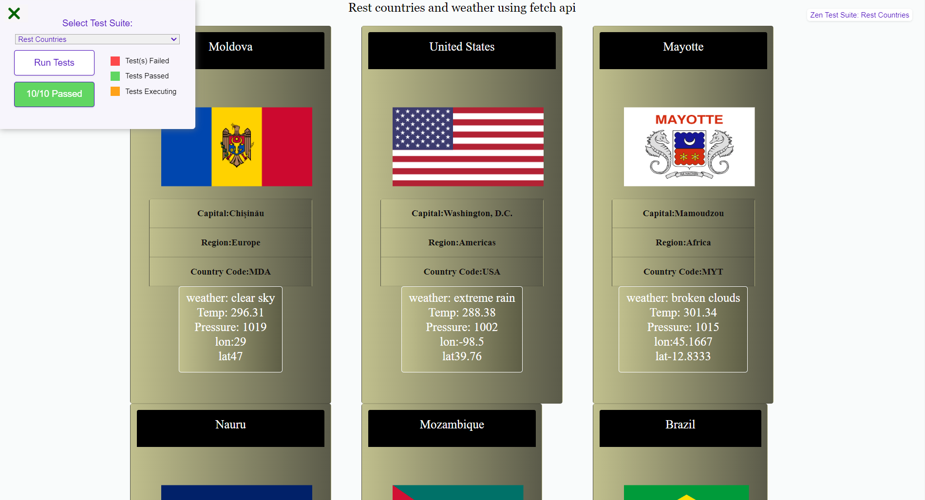

* Completed the Rest country API. When working on it the rest country API failed to load. But now its working file.